INDEX

1.0Real time passenger count module 6

1.1Prerequisite 6

1.2Developing an Android application 6

1.3Interfacing Bluetooth module (HC-05) with Arduino 9

2.0Working of Real time passenger count module 10

3.0What is GPS? 14

3.1How GPS Determines a Position: 14

3.2Advantages of GPS: 15

3.3Neo 6m gps module 15

3.4Features of NEO 6M 16

4.0What is html? 17

4.1Screenshots of website page 18

4.2Advantages of CSS 21

4.3History of css 22

4.4What is responsive? 22

4.5Media Queries 23

5.0What is JavaScript? 23

5.1What can JavaScript do in-browser? 24

5.2What CAN’T in-browser JavaScript do? 24

6.0What is Python Programming Language? 26

6.1Usage Of Python Programming Language 27

7.0Data Flow Diagram 28

7.1Web server 29

7.2Client web site 29

7.3Analysis of data from data base by admin 30

8.0References 31

**Figure Index**

Figure 1: Android logo 8

Figure 2 MIT logo 9

Figure 3: Block code 9

Figure 4: QR scanner code app 10

Figure 5: Bluetooth module 11

Figure 6: Interface of Arduion and Bluetooh module 11

Figure 7: Process Flow Diagram 15

Figure 8: Determines a Position by GPS 16

Figure 9: GPS module 17

Figure 10: website site screenshort 1 20

Figure 11: website site screenshort 2 21

Figure 12: website site screenshort 3 21

Figure 13: website site screenshort 4 22

Figure 14: How HTML work 22

Figure 15: Responsive web page 26

Figure 16: working of HTTP 28

Figure 17: Data flow diagram 32

# Real time passenger count module

This module will provide the feature to the user that he or she can be able to get information on passenger count in any vehicle of a public transportation system. This information will be able to help to user that from which mode she wants to travel. This module will also provide users with how many vacant seats are available so that they can comfortably complete the journey without any hassle. So we can say that the customers of the public transportation system will have a satisfaction journey and have value for money. This will help the transportation provider generate more revenue and also some important data like when are the rush hours, the peak days, and frequency at any time so the service provider will be able to predict accurately how much reinforcement it will need to fulfill the demand. And also helps to autonomies the ticketing system and database building of passengers.

## Prerequisite

To develop this module we will need an Android app, Bluetooth module (HC-05), Arduino UNO development board, Arduino IDE (integrated development environment). These components are needed to develop this module of automatic ticketing system.

## Developing an Android application

Android is a [mobile operating system](https://en.wikipedia.org/wiki/Mobile_operating_system) developed by [Google](https://en.wikipedia.org/wiki/Google), based on a modified version of the [Linux kernel](https://en.wikipedia.org/wiki/Linux_kernel) and other [open source](https://en.wikipedia.org/wiki/Open_source) software and designed primarily for [touchscreen](https://en.wikipedia.org/wiki/Touchscreen) mobile devices suchsmartphones and tablets.



Figure 1: Android logo

An Android app is a software application running on the Android platform. Because the Android platform is built for mobile devices, a typical Androidapp is designed for a smartphone or a tablet PC running on the Android OS.

The main purpose for developing an android app is to demonstrate how to scan the QR code of the adharcard with the help of an android smart phone application. To do so we have developed an android app with the help of MIT app inventor 2. App Inventor for Android is an open-source web application originally provided by Google, and now maintained by the Massachusetts Institute of Technology (MIT). It allows newcomers to computer programming to create software applications for the Android operating system (OS).



Figure 2 MIT logo

This environment is based on block and tiles based programing environment, which doesn’t need a thorough knowledge of programing language used to develop android app like JAVA. The below figure shows the block code use for develop the QR code scanner app.

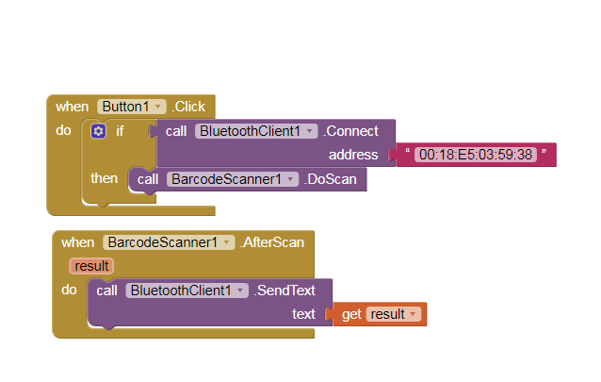

Figure 3: Block code

As you see in the figure there are several blocks which will run when the use will touch the button which is provided in the user interface of the app.

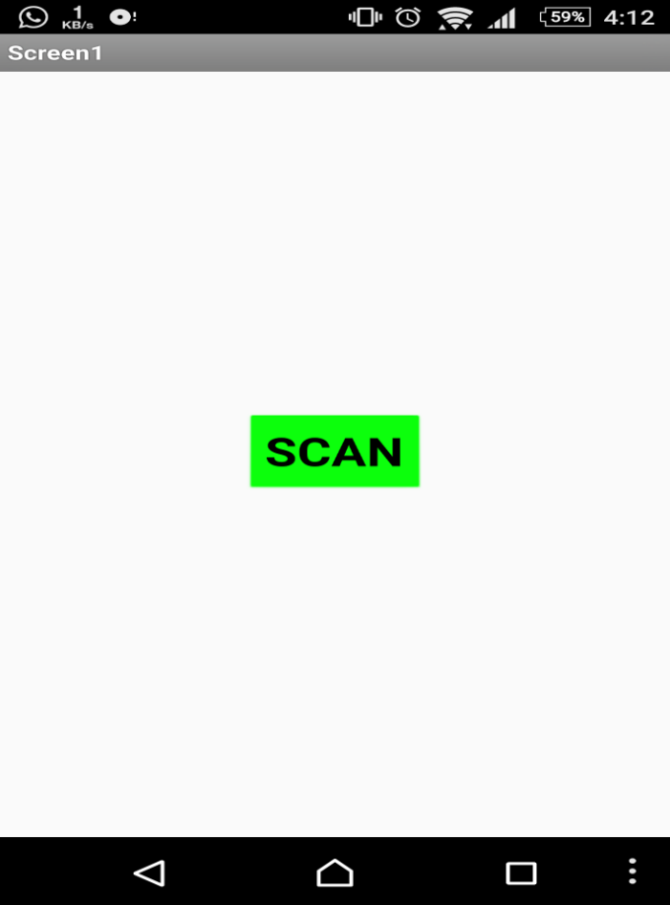

Figure 4: QR scanner code app

Whenever this green button is pressed in the backhand the application will turn on the Bluetooth module of the smartphone device and connect to MAC address (00:18:E5:03:59:38) which is a Bluetooth device (HC-05), interfaced with Arduino UNO the HC-05 Bluetooth module which is interfaced with Arduino UNO, then app will run Zxing library which is used for barcode scanning and QR code scanning program. After the successful recognition of Adharcard QR code it will send the information of that card via mobile Bluetooth to Bluetooth module interfaced to the development board. And then it will terminate the process and again shows this button to next customer who wants to use the transportation.

## Interfacing Bluetooth module (HC-05) with Arduino

Here we use an hardware module called HC-05, which is basically a Bluetooth module and compatible to easily interfaced to the Arduino so it is a slave device.it needs ground pin and 5v power supply and it comprises Tx(transmission) pin and one Rx(receiving) pin. It uses serial communication to protocol SPI to communicate with master device which it is interfaced.

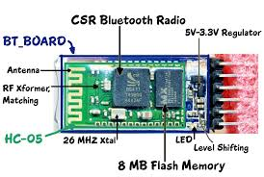

Figure 5: Bluetooth module

HC-05 module is an easy to use Bluetooth SPP (Serial Port Protocol) module, designed for transparent wireless serial connection setup. Serial port Bluetooth module is fully qualified Bluetooth V2.0+EDR (Enhanced Data Rate) 3Mbps Modulation with complete 2.4GHz radio transceiver and baseband. It uses CSR Bluecore 04-External single chip Bluetooth system with CMOS technology and with AFH(Adaptive Frequency Hopping Feature). It has the footprint as small as 12.7mmx27mm. Hope it will simplify your overall design/development cycle.

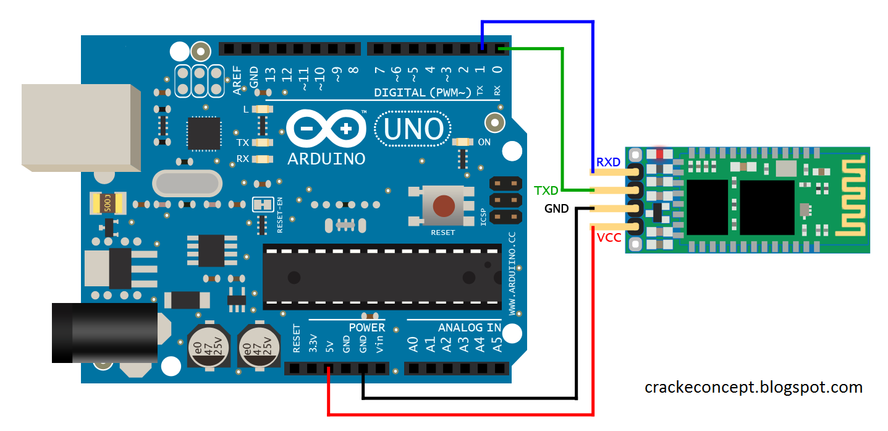

Figure 6: Interface of Arduion and Bluetooh module

As you can see in above circuit diagram some Arduino board IO pins are attached with HC-05 module, the Tx pin of HC-05 module is attached with Rx pin of the Arduino board and vice versa. When HC-05 wants to send any massage to Arduino in sends and signal that to wants to send data and then Arduino starts to listen and the Arduino receives the data store it in the buffer memory. When the android app has sent QR code data of the adharcard to the HC-05 module, the HC-05 module will first save that data to its flash memory and then it will send and initiation signal to the Arduino and pass on the adharcard data to the Arduino board.

# Working of Real time passenger count module

In this part of the report we have summarized and described that how the Arduino code will be executed and how will Arduino save the data of the passengers.

In this section of report we are going to describe how the Arduino code is going to execute.

inti;

int p;

int k;

String scan[150];

String readString;

void setup(){

Serial.begin(9600);

}

void loop(){

Serial.println("scan the QR code ");

while (Serial.available()==0){

}

for(i=1;i<150;i++){

while (Serial.available()==0){

}

while (Serial.available())

{

delay(3); sub module-1

char c = Serial.read();

readString += c;

}

scan[i]=readString;

Serial.println(readString);

readString="";

for(k=1;k<=i;k++){

if(scan[i]==scan[i-k])

{scan[i]=scan[i-k]=readString=""; sub module -2

p=p-2;

break;

}

}p=p+1;

Serial.println(p);

}

}

To describe the above code in brief I have dived this code in to two sub modules. The 1st module depicts how the data will be received serially to the Arduino board via HC-05 module. The HC-05 module will transmit each character of data to Arduino at 9600 baud rate. After sending one character it will call deal of 3ms to ensure that all the bits of the character has been received successfully.

The 2nd module of this code depicts that firstly it will store the received data and then check weather this data exists in the data base or not. If the data is already exists then it will be cleared and decreases the count by 1 else it does not matches then the counter will increased by 1.

“THE COUNTER VALUE DEPICTS THE RAL TIME PASSANGER IN PERTICULAR VEHICAL”.

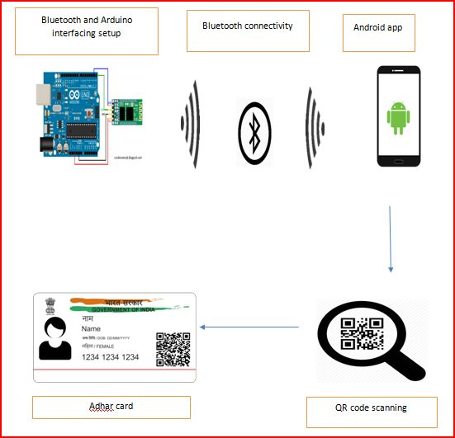

Figure 7: Process Flow Diagram

# What is GPS?

GPS or Global Positioning System is a satellite navigation system that furnishes location and time information in all climate conditions to the user. GPS is used for navigation in planes, ships, cars and trucks also. The system gives critical abilities to military and civilian users around the globe. GPS provides continuous real time, 3-dimensional positioning, navigation and timing worldwide.

## How GPS Determines a Position:

The working/operation of Global positioning system is based on the ‘trilateration’ mathematical principle. The position is determined from the distance measurements to satellites. From the figure, the four satellites are used to determine the position of the receiver on the earth. The target location is confirmed by the 4th satellite. And three satellites are used to trace the location place. A fourth satellite is used to confirm the target location of each of those space vehicles. Global positioning system consists of satellite, control station and monitor station and receiver. The GPS receiver takes the information from the satellite and uses the method of triangulation to determine a user’s exact position.

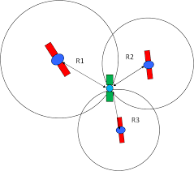

Figure 8: Determines a Position by GPS

## Advantages of GPS:

GPS satellite based navigation system is an important tool for military, civil and commercial users.

Vehicle tracking systems GPS-based navigation systems can provide us with turn by turn directions.

## Neo 6m gps module

The NEO-6M GPS module is a well-performing complete GPS receiver with a built-in 25 x 25 x 4mm ceramic antenna, which provides a strong satellite search capability. With the power and signal indicators, you can monitor the status of the module. Thanks to the data backup battery, the module can save the data when the main power is shut down accidentally. Its 3mm mounting holes can ensure easy assembly on your aircraft, which thus can fly steadily at a fixed position, return to Home automatically, and automatic waypoint flying, etc.

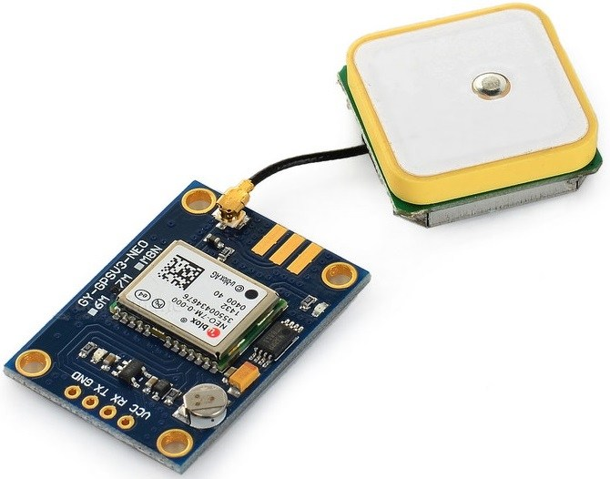

Figure 9: GPS module

## 

## Features of NEO 6M

1. A complete GPS module with an active antenna integrated, and a built-in EEPROM to save configuration parameter data.
2. Built-in 25 x 25 x 4mm ceramic active antenna provides strong satellite search capability.
3. Equipped with power and signal indicator lights and data backup battery.
4. Power supply: 3-5V; Default baud rate: 9600bps.
5. Interface: RS232 TT

# What is html?

HTML is a computer language devised to allow website creation. These websites can then be viewed by anyone else connected to the Internet. It is relatively **easy to learn**, with the basics being accessible to most people in one sitting; and quite **powerful** in what it allows you to create. It is constantly undergoing revision and evolution to meet the demands and requirements of the growing Internet audience under the direction of the organisation charged with designing and maintaining the language.

The definition of HTML is **Hypertext Markup Language**.

Hypertext is the method by which you move around on the web — by clicking on special text called **hyperlinks** which bring you to the next page. The fact that it is hyper just means it is not linear — i.e. you can go to any place on the Internet whenever you want by clicking on links — there is no set order to do things in.

Markup is what **HTML tags** do to the text inside them. They mark it as a certain type of text (italicized text, for example).

HTML is a Language, as it has code-words and syntax like any other language.

## Screenshots of website page

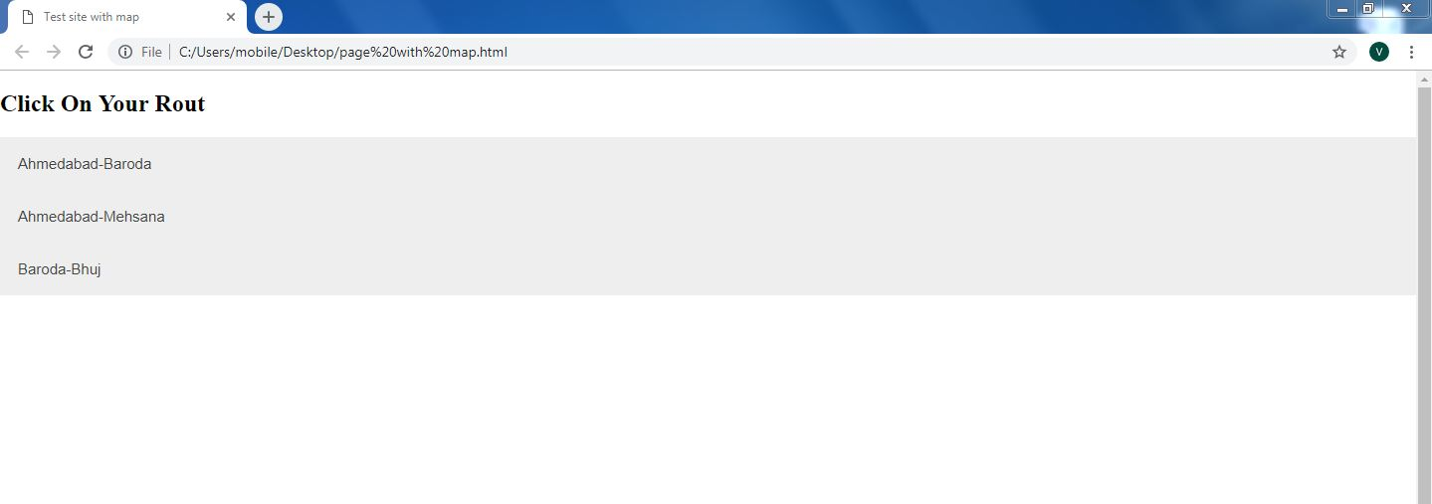

Figure 10: website site screenshort 1

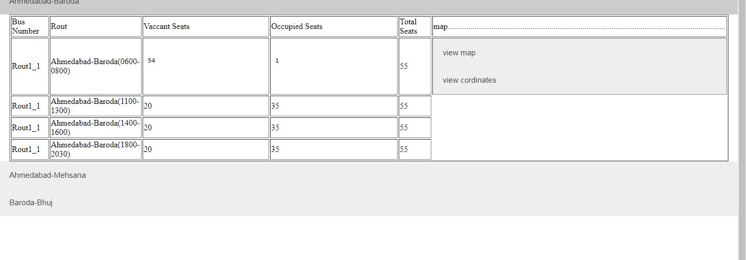

Figure 11: website site screenshort 2

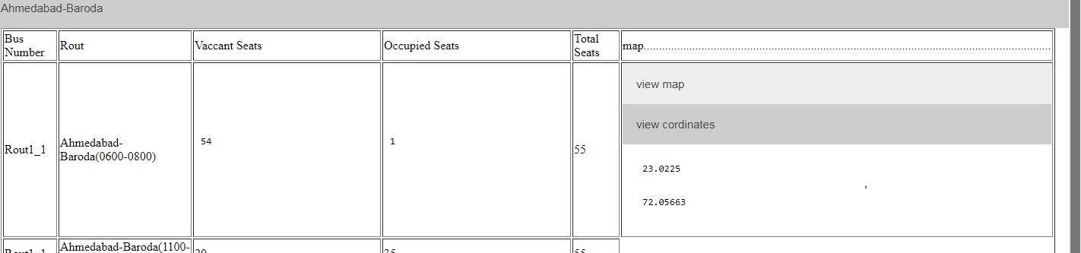

Figure 12: website site screenshort 3

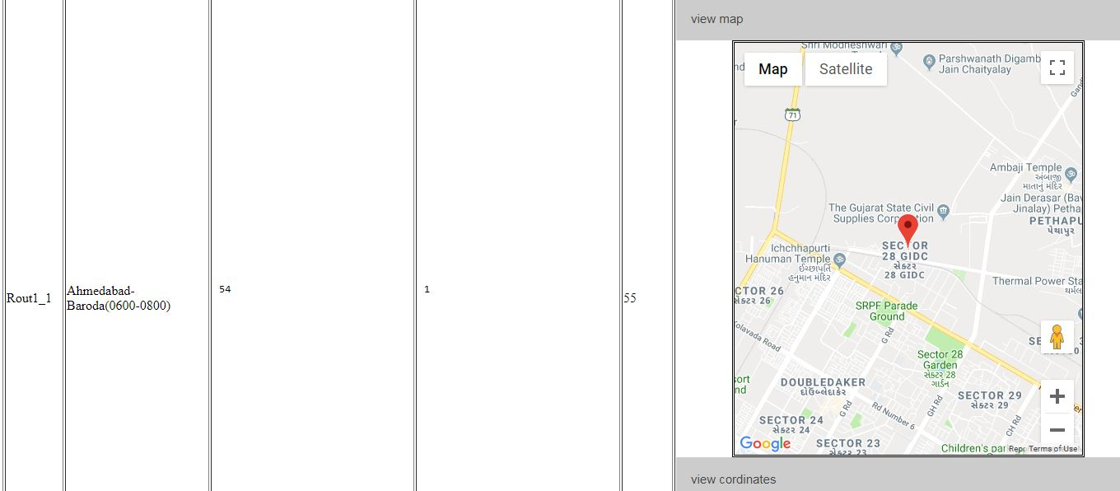

Figure 13: website site screenshort 4

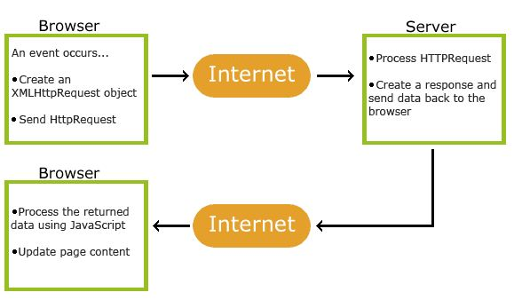

Figure 14: How HTML work

HTML consists of a series of short **codes** typed into a text-file by the site author — these are the tags. The text is then **saved as a html file**, and **viewed through a**[**browser**](https://www.yourhtmlsource.com/starthere/glossary.html#browser), like Internet Explorer or Netscape Navigator. This browser reads the file and translates the text into a visible form, hopefully rendering the page as the author had intended. Writing your own HTML entails using tags correctly to create your vision. You can use anything from a rudimentary text-editor to a powerful graphical editor to create HTML pages.

**What html can’t do?**

Of course, but since making websites became more popular and needs increased many other supporting languages have been created to allow new stuff to happen, plus HTML is [modified every few years](https://www.yourhtmlsource.com/starthere/historyofhtml.html) to make way for improvements.

[**Cascading Style sheets**](https://www.yourhtmlsource.com/stylesheets/) are used to control how your pages are presented, and make pages more accessible. Basic special effects and interaction is provided by [JavaScript](https://www.yourhtmlsource.com/javascript/), which adds a lot of power to basic HTML. Most of this advanced stuff is for later down the road, but when using all of these technologies together, you have a lot of power at your disposal.

**C**ascading **S**tyle **S**heets, fondly referred to as CSS, is a simple design language intended to simplify the process of making web pages presentable.

CSS handles the look and feel part of a web page. Using CSS, you can control the color of the text, the style of fonts, the spacing between paragraphs, how columns are sized and laid out, what background images or colors are used, layout designs and variations in display for different devices and screen sizes as well as a variety of other effects.

CSS is easy to learn and understand but it provides powerful control over the presentation of an HTML document. Most commonly, CSS is combined with the markup languages HTML or XHTML.

## Advantages of CSS

**CSS saves time** − you can write CSS once and then reuse same sheet in multiple HTML pages. You can define a style for each HTML element and apply it to as many Web pages as you want.

**Pages load faster** − If you are using CSS, you do not need to write HTML tag attributes every time. Just write one CSS rule of a tag and apply it to all the occurrences of that tag. So less code means faster download times.

**Easy maintenance** − To make a global change, simply change the style, and all elements in all the web pages will be updated automatically.

**Superior styles to HTML** − CSS has a much wider array of attributes than HTML, so you can give a far better look to your HTML page in comparison to HTML attributes.

**Multiple Device Compatibility** − Style sheets allow content to be optimized for more than one type of device. By using the same HTML document, different versions of a website can be presented for handheld devices such as PDAs and cell phones or for printing.

**Global web standards** − Now HTML attributes are being deprecated and it is being recommended to use CSS. So it’s a good idea to start using CSS in all the HTML pages to make them compatible to future browsers.

## History of css

CSS was first proposed by Haakon Wium Lie on October 10, 1994. At the time, Lie was working with Tim Berners-Lee at CERN. Several other style sheet languages for the web were proposed around the same time, and discussions on public mailing lists and inside World Wide Web Consortium resulted in the first W3C CSS Recommendation (CSS1) being released in 1996. In particular, a proposal by Bert Bos was influential; he became co-author of CSS1, and is regarded as co-creator of CSS.

Style sheets have existed in one form or another since the beginnings of Standard Generalized Markup Language (SGML) in the 1980s, and CSS was developed to provide style sheets for the web. One requirement for a web style sheet language was for style sheets to come from different sources on the web. Therefore, existing style sheet languages like DSSSL and FOSI were not suitable. CSS, on the other hand, let a document's style be influenced by multiple style sheets by way of "cascading" styles.

## What is responsive?

Responsive Web Design is about using HTML and CSS to automatically resize a website.

Responsive Web Design is about making a web side look good on all devices (desktops, tablets, and phones):

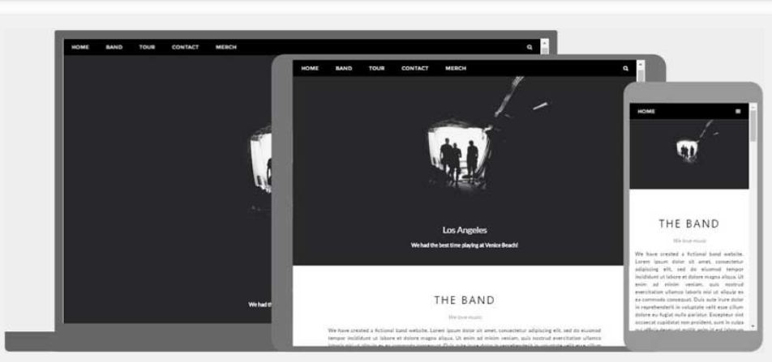

Figure 15: Responsive web page

## Media Queries

Media Queries plays an important role in responsive web pages.

With media queries you can define different styles for different browser sizes

# What is JavaScript?

JavaScript was initially created to “make web pages alive”.

The programs in this language are called scripts. They can be written right in a web page’s HTML and executed automatically as the page loads.

Scripts are provided and executed as plain text. They don’t need special preparation or compilation to run.

In this aspect, JavaScript is very different from another language called Java.

## 

## [What can JavaScript do in-browser?](https://javascript.info/intro#what-can-in-browser-javascript-do)

Modern JavaScript is a “safe” programming language. It does not provide low-level access to memory or CPU, because it was initially created for browsers which do not require it.

JavaScript’s capabilities greatly depend on the environment it’s running in. For instance, Node.JS supports functions that allow JavaScript to read/write arbitrary files, perform network requests, etc.

In-browser JavaScript can do everything related to webpage manipulation, interaction with the user, and the web server.

For instance, in-browser JavaScript is able to:

Add new HTML to the page, change the existing content, and modify styles.

React to user actions, run on mouse clicks, pointer movements, and key presses.

Send requests over the network to remote servers, download and upload files (so-called AJAX and COMET technologies).

Get and set cookies, ask questions to the visitor, show messages.

Remember the data on the client-side (“local storage”).

## [What CAN’T in-browser JavaScript do?](https://javascript.info/intro" \l "what-can-t-in-browser-javascript-do)

JavaScript’s abilities in the browser are limited for the sake of the user’s safety. The aim is to prevent an evil webpage from accessing private information or harming the user’s data.

Different tabs/windows generally do not know about each other. Sometimes they do, for example when one window uses JavaScript to open the other one. But even in this case, JavaScript from one page may not access the other if they come from different sites (from a different domain, protocol or port).

This is called the “Same Origin Policy”. To work around that, both pages must contain a special JavaScript code that handles data exchange.

This limitation is, again, for the user’s safety. A page from http://anysite.com which a user has opened must not be able to access another browser tab with the URL http://gmail.com and steal information from there.

JavaScript can easily communicate over the net to the server where the current page came from. But its ability to receive data from other sites/domains is crippled. Though possible, it requires explicit agreement (expressed in HTTP headers) from the remote side. Once again, that’s a safety limitation.

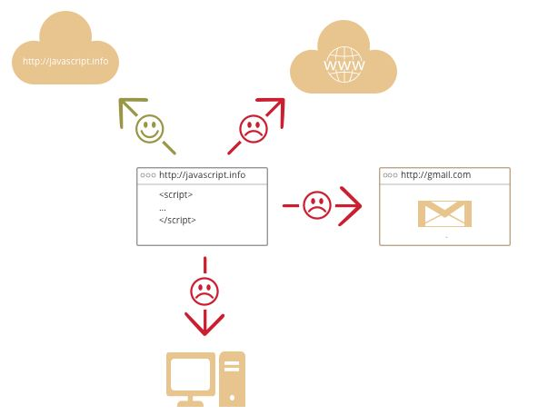

Figure 16: working of HTTP

Such limits do not exist if JavaScript is used outside of the browser, for example on a server. Modern browsers also allow plugin/extensions which may ask for extended permissions.

**What makes JavaScript unique?**

**There are at least three great things about JavaScript:**

Full integration with HTML/CSS. Simple things are done simply.Support by all major browsers and enabled by default. JavaScript is the only browser technology that combines these three things. That’s what makes JavaScript unique. That’s why it’s the most widespread tool for creating browser interfaces. While planning to learn a new technology, it’s beneficial to check its perspectives. So let’s move on to the modern trends affecting it, including new languages and browser abilities.

# What is Python Programming Language?

Python is an interpreted, high-level, general-purpose programming language. Created by Guido van Rossum and first released in 1991, Python has a design philosophy that emphasizes code readability, notably using significant whitespace. It provides constructs that enable clear programming on both small and large scales. Van Rossum led the language community until stepping down as leader in July 2018.

Python features a dynamic type system and automatic memory management. It supports multiple programming paradigms, including object-oriernted, imperative, functional and procedural. It also has a comprehensive standard library.

Python was conceived in the late 1980s by Guido van Rossum at Centrum Wiskunde & Informatics (CWI) in the Netherlands as a successor to the ABC language (itself inspired by SETL), capable of exception handling and interfacing with the Amoeba operating system. Its implementation began in December 1989. Van Rossum's long influence on Python is reflected in the title given to him by the Python community: Benevolent Dictator For Life (BDFL) – a post from which he gave himself permanent vacation on July 12, 2018.

## Usage Of Python Programming Language

Application of Python is used to simplifying the complex software development process as it is a general-purpose programming language. It is used for developing the complex application like scientific and numeric application, and for both desktop and web applications.

Python is a general-purpose language, which means it can be used to build just about anything, which will be made easy with the right tools/libraries. Professionally, Python is great for backend web development, data analysis, artificial intelligence, and scientific computing.

# Data Flow Diagram

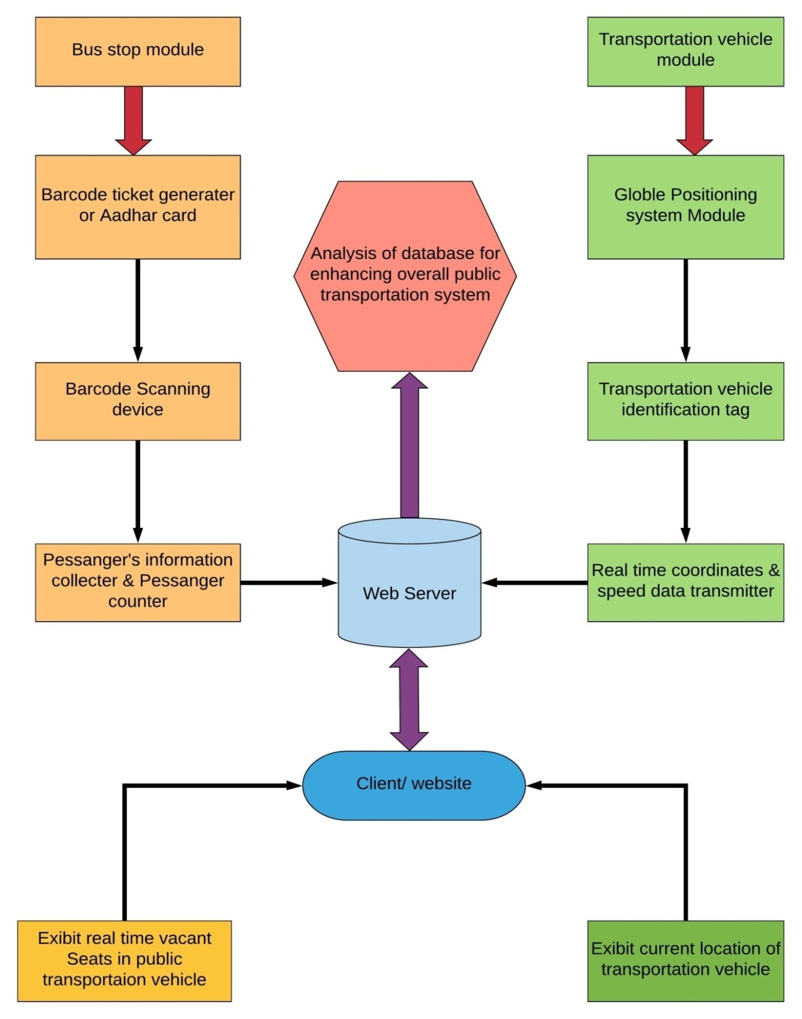

Figure 17: Data flow diagram

## Web server

Basically we have hosted our web server in our pc itself it simply means that we have local hosted the site. Internet information service or iis we have used for local hosting the site. It is the free service provided by the windows. All the data coming from the different modules are saved in the text file and the web site which is designed using the html and css are using these text file as a data source. We can use different authentication levels for the access of the files and it will be good all don’t have access to all the things.

## Client web site

This web site will be accessible to the end use the user will get this on web. This site is also hosted on local host using iis for demo purpose. The details regarding the vehicle and the location based on that he can make the decisions. The most interesting part of the project is applicator here only the user will be able to see the real time vacancy in the bus which is the most useful and the unique thing in this system. The data from the Arduino fetched by in the text file and we have processed that in local host using some code in python. The number of passenger is counted in the ardiuno board itself and the data from ardiuno is saved in the web server and the all thing are displayed well in the web page. the location from the gps module is coming to the ardiuno bord using the com port but it is only visible open the com port display move the ardiuno but it doesn’t look well and the thing are not working in the desired manner so we have used python based code which is having the work of converting the data coming from the com port which is visible in the serial monitor we can convert in human readable form and the data is automatically convert ted to the txt file and the text file can be readable to the html page as a data source. Path of the file is written and provided in the homepage and it is capable of the reading the txt file. The latitude and longitude which is saved in the text file is read and the maps are opened as per the data.using the I frame we have use the service of Google called Google api the api we have to ask from Google it self all the api key is unique and limited permission is given to each key. The coordinates are enough to find the location of bus and the map is being displayed. The location can tell us the position and the time which the bus will take to reach at your location.

## Analysis of data from data base by admin

The data is saved in the database and the things which are necessary are done in that data. User has only a limited level of access to the data. For future analysis, we will be able to accurately predict passenger traffic on any particular root. This will help to how many vehicles should be assign to any particular root for any particular time, so we. In addition, analysis of the data available will also be help full in other factors like investigation of any cases. After collecting vast amount of over a significant amount of period, we will have.

# References

[**https://www.azosensors.com/article.aspx?ArticleID=310**](https://www.azosensors.com/article.aspx?ArticleID=310)

[**https://circuitdigest.com/microcontroller-projects/tachometer-using-arduino**](https://circuitdigest.com/microcontroller-projects/tachometer-using-arduino)

[**http://appinventor.mit.edu/explore/get-started.html**](http://appinventor.mit.edu/explore/get-started.html)

[**http://appinventor.mit.edu/explore/about-us.html**](http://appinventor.mit.edu/explore/about-us.html)

**https://play.google.com/store/apps/details?id=edu.mit.appinventor.aicompanion3&hl=en**